Project Name:

**Calculator of Shapes**

Date: 18-06-2022

Revision History

| Version No | Date | Prepared by / Modified by | Description |
| --- | --- | --- | --- |
| <1.0> | 18/06/2022 | Team B | SRS |

**Table Of Contents**

1.1 Project Overview 3

1.2 Scope 3

1.3 Intended Audience 3

1.4 High Level Usecases…………………………………………………………………………………4

1.5 Use Cases Detalied…………………………………………………………………………………..5

1.6 User Interface Modules………………………………………………………………………………6

1.7 Technical detailed description……………………………………………………………………….7

1.8 Sequeance Diagram………………………………………………………………………………….8

1.9 Standards…………………………………………………………………………………………………………………………….9

## **1.1Project Overview**

Calculator of Shapes

The introduction of the Software Requirements Specification (SRS) provides an overview of the entire SRS with purpose, scope, definitions, references and overview of the SRS. The aim of this document is to gather and analyze and give an in-depth insight of the calculator of shapes.

Here we will tell about detailed requirements of the calculator of shapes project in this document.

## **PURPOSE**

The purpose of the document is to collect and analyze all assorted ideas that have come up to

Calculator of shapes is we need to calculate the areas, perimeter and all other things of

*Equilateral Triangle*

*Square*

*Pentagon*

*Hexagon*

*Rectangle*

*Circle*

*Cube*

*Cylinder*

*Sphere*

In this project we can calculate different types of shapes areas and perimeter.

## **1.2 Scope**

In scope will write the code for calculator of shapes where we will specify each and every shape and we will calculate their perimeters, areas and all other things.

## **1.3Intended Audience**

This helps to school students for better grip in calculating shapes

## 

## **1.4High Level Use Cases**

* Here We have written High level use cases scenarios

## 

## 

## **1.5Use Cases detailed**

The use cases we used in project are

Please Enter a number between 1 and 9 to make a decision or 10 to Quit

For regular and irregular shapes choose between 1 and 6 as shown below

1 = Equilateral Triangle

2 = Square

3 = Pentagon

4 = Hexagon

5 = Rectangle

6 = Circle

For Solid shapes choose between 7 and 9 as shown below

7 = Cube

8 = Cylinder

9 = Sphere

Select 10 to Quit

2

You selected Square

Enter your number to represent 1 side

5

Your perimeter is: 20.0 cm and your Area is: 10.0 cm square.

10

You decided to Quit.

Sample Input and Output 2:

Please Enter a number between 1 and 9 to make a decision or 10 to Quit

For regular and irregular shapes choose between 1 and 6 as shown below

1 = Equilateral Triangle

2 = Square

3 = Pentagon

4 = Hexagon

5 = Rectangle

6 = Circle

For Solid shapes choose between 7 and 9 as shown below

7 = Cube

8 = Cylinder

9 = Sphere

Select 10 to Quit

7

You selected Cube

Enter your number to represent 1 side/edge of your Cube

5

Your Volume is: 125.0 cubic cm and your Surface Area is: 150.0 cm square.

9

You selected Sphere

Enter your Radius

4

Your Volume is: 268.082573106329 cubic cm and your Surface Area is: 201.06192982974676 cm square.

6

You selected Circle

Enter the radius for your circle

6

Your perimeter (circumference in this case) is: 37.69911184307752 cm and your Area is: 113.09733552923255 cm square.

10

You decided to Quit.

## **1.6User Interface Modules**

It is a Console Interface Module.

## **1.7Technical Detailed Description**

## For this project and writing the code we have chosen java and in that we have used if method and break commands in order to deliver our project.

## **1.8Sequence Diagram**

* Here is the Sequence diagram

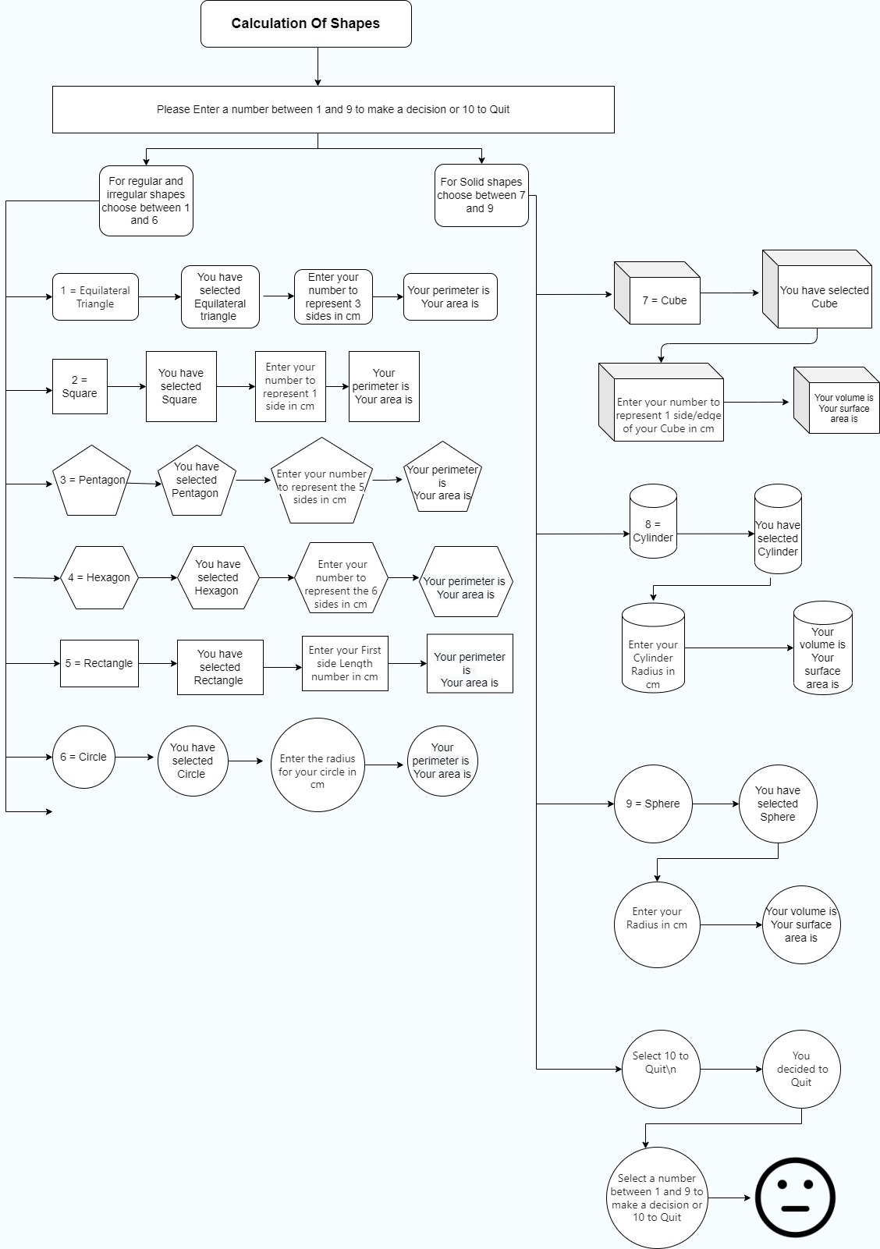

## **1.9Standards**

**Terminologies:**

* *Equilateral Triangle*
* *Square*
* *Pentagon*
* *Hexagon*
* *Rectangle*
* *Circle*
* *Cube*
* *Cylinder*
* *Sphere*
* *Switch cases*
* *Break*
* *Shapes*
* *Area*
* *Perimeter*
* *Volume*
* *Surface area*
* *Radius*
* *Height*
* *PI*
* *Centimeter*
* *Square Centimeter*
* *Cubic Centimeter*